关于斯蒂芬妮 Stephanie Tisone 事件，是网上流传很广的一篇声讨安东尼是骗子的文章，说安东尼的一位年轻助手斯蒂芬妮罹患乳癌去世了，其间没有获得安东尼的有效帮助。安东尼的电台是有对这事回应的。想详细了解的话，可以听他的电台完整录音。下面只是一些零碎的提要摘抄和软件翻译，另外我加了个安友疗愈乳癌的案例分享：
链接：https://www.medicalmedium.com/blog/for-steph-the-untold-story
Her name is Stephanie Tisone and she passed away from Breast Cancer in 2018. A tragic loss that has broken the hearts of the ones that knew her and loved her. There have been rumors of how this tragedy occurred and the influence of Medical Medium. How is it possible Stephanie died from Breast Cancer, especially when Stephanie seemed so healthy, vibrant and involved in the health world and being a Raw Vegan eating nothing but fruits and vegetables? A group of people colluded and brought Stephanie’s story to a mainstream media outlet. But was it the real story? Stephanie was used for click bait and exploited and her name and memory trashed. Was there an agenda that was far from telling the true story and filled with misinformation of what happened to Stephanie Tisone? Get ready to hear the untold story of Stephanie and the factual evidence of what really happened.

Want to know what happened to Stephanie Tisone?
她的名字叫斯蒂芬妮-蒂松（Stephanie Tisone），2018 年因乳腺癌去世。这场悲剧让认识她、爱她的人心碎。关于这场悲剧是如何发生的，以及医学媒介的影响，一直都有传言。斯蒂芬妮怎么可能死于乳腺癌，尤其是斯蒂芬妮看起来如此健康、充满活力，而且还参与了健康世界的活动，是一个只吃水果和蔬菜的生素食主义者？一群人串通一气，将斯蒂芬妮的故事搬上了主流媒体。但这是真实的故事吗？斯蒂芬妮被用作点击诱饵，被人利用，她的名字和记忆被毁。斯蒂芬妮-蒂松的遭遇是否与真实故事相去甚远，并充满了错误信息？准备好聆听斯蒂芬妮不为人知的故事和真实发生的事实证据吧。

想知道斯蒂芬妮-蒂松的遭遇吗？
说是虚假的故事，这是一位母亲一个半小时的电台采访录音。她说她是Stephanie Tisone的密友。在Stephanie Tisone生病期间一直给予她各方面的帮助和支持，包括买营养素给她，给她做饭等等照顾。
064 The Plotter Series S2 E4: Plotters Bully A Mother And Her Children
链接：https://podcasts.apple.com/us/podcast/064-the-plotter-series-s2-e4-plotters-bully-a/id1133835109?i=1000664052953
这里有一段采访视频片段：https://www.tiktok.com/@medicalmedium/video/7398946175807753514
A mother who healed from Lyme disease and has been utilizing Medical Medium information for years is interviewed to discuss her experiences as someone who was close friends with Stephanie Tisone and has had many interactions with the plotters. Kimberly Spair was physically present to witness what really happened with Stephanie while Ashleigh Foster, the number one plotter who has tried to assert herself as an authority on the matter in order to corruptly secure a documentary deal, was not present for any single part of Stephanie’s illness. Kimberly opens up about how she has been traumatized by the many painful and ruthless attacks that have been directed at her by plotters over the years, and about how she still has PTSD because of it. Some of the early plotter attacks severely impacted Kimberly’s physical health, and the attacks have only increased since Kimberly refused to cooperate with Ashleigh’s original false story about Stephanie in 2020 that Kimberly knew firsthand to be fabricated. One of the most recent public attacks from Ashleigh Foster, disturbingly, was directed at Kimberly’s children, who were all under the age of 9 at the time. In this episode, Kimberly exposes many new contradictions and falsities amongst the plotters regarding Stephanie Tisone. Kimberly also shares about the fallout she witnessed from a portion-controlled weight loss program that Ashleigh Foster created, marketed, and sold to postpartum women in the community–even long after Stephanie passed away–as if it were Medical Medium information when it was not, which caused many of these women to lose their supply of breast milk and blame Medical Medium for it because they were confused by Ashleigh.
一位莱姆病痊愈的母亲多年来一直在利用医学媒介信息，她作为斯蒂芬妮-蒂松的密友接受了采访，讨论了自己的经历，并与策划者进行了多次互动。金伯利-斯派尔亲眼目睹了斯蒂芬妮的真实病情，而阿什利-福斯特，这位头号谋划者，却没有参与斯蒂芬妮病情的任何一个环节，她曾试图以权威人士自居，以贪婪的手段获得纪录片合约。金伯利坦言，多年来，她曾多次遭受密谋者痛苦而无情的攻击，心灵受到创伤，至今仍有创伤后应激障碍。一些早期策划者的攻击严重影响了金伯利的身体健康，自从金伯利拒绝与阿什利合作，最初在 2020 年编造了关于斯蒂芬妮的虚假故事以来，攻击就有增无减。令人不安的是，阿什莉-福斯特最近的一次公开攻击是针对金伯利的孩子，当时他们都还不到 9 岁。在本集节目中，金伯利揭露了密谋者之间关于斯蒂芬妮-蒂松的许多新的矛盾和谎言。金佰利还分享了她亲眼目睹的阿什莉-福斯特（Ashleigh Foster）创建、推销并向社区产后妇女出售的分量控制减肥计划所造成的后果--甚至在斯蒂芬妮去世很久之后--就好像这是《医学媒介》的信息，而事实并非如此，这导致许多妇女失去母乳供应，并因为被阿什莉迷惑而将责任归咎于《医学媒介》。【通过DeepL.com（免费版）翻译】

博主我在这里插个话吧，其实疗愈各种癌症，包括疗愈乳腺癌的安友分享是颇为不少的。而且大多数乳腺癌患者比文中所说的这位安东尼助手年纪要大很多，人家都疗愈了。比如，下面就是其中一位乳癌痊愈的患者图文分享，以及软件翻译：
（注：软件自动翻译的一个明显的错误，她是在诊断出乳腺癌的前几个月开始安疗的，而不是过去几个月才开始。另外，文中提到的“高级hmds”，就是“增强版的重金属排毒果昔”的意思。每天64盎司西芹汁就是2升西芹汁。这些都是安疗中的重要措施之一。）

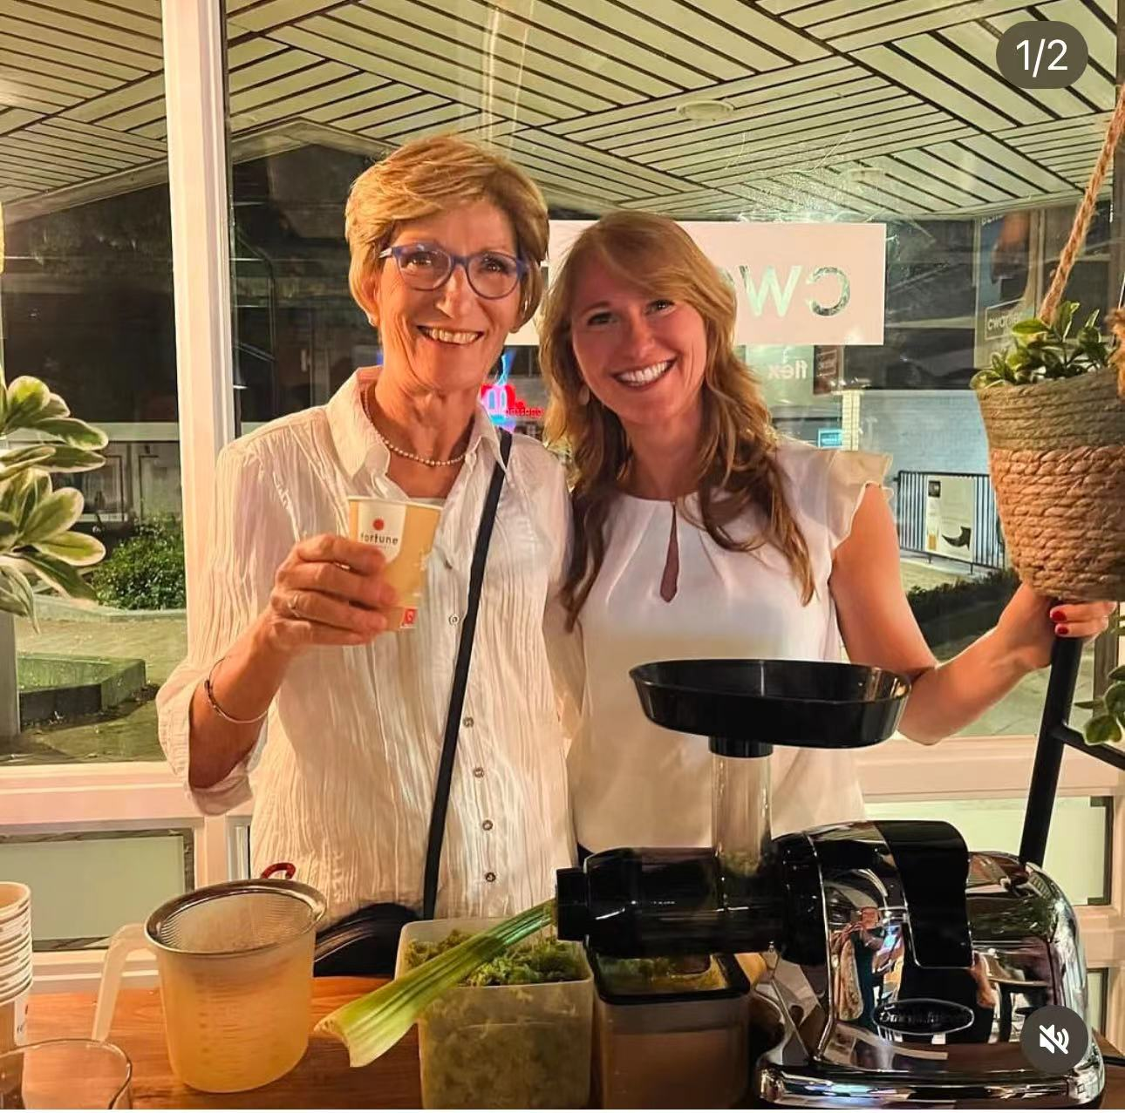

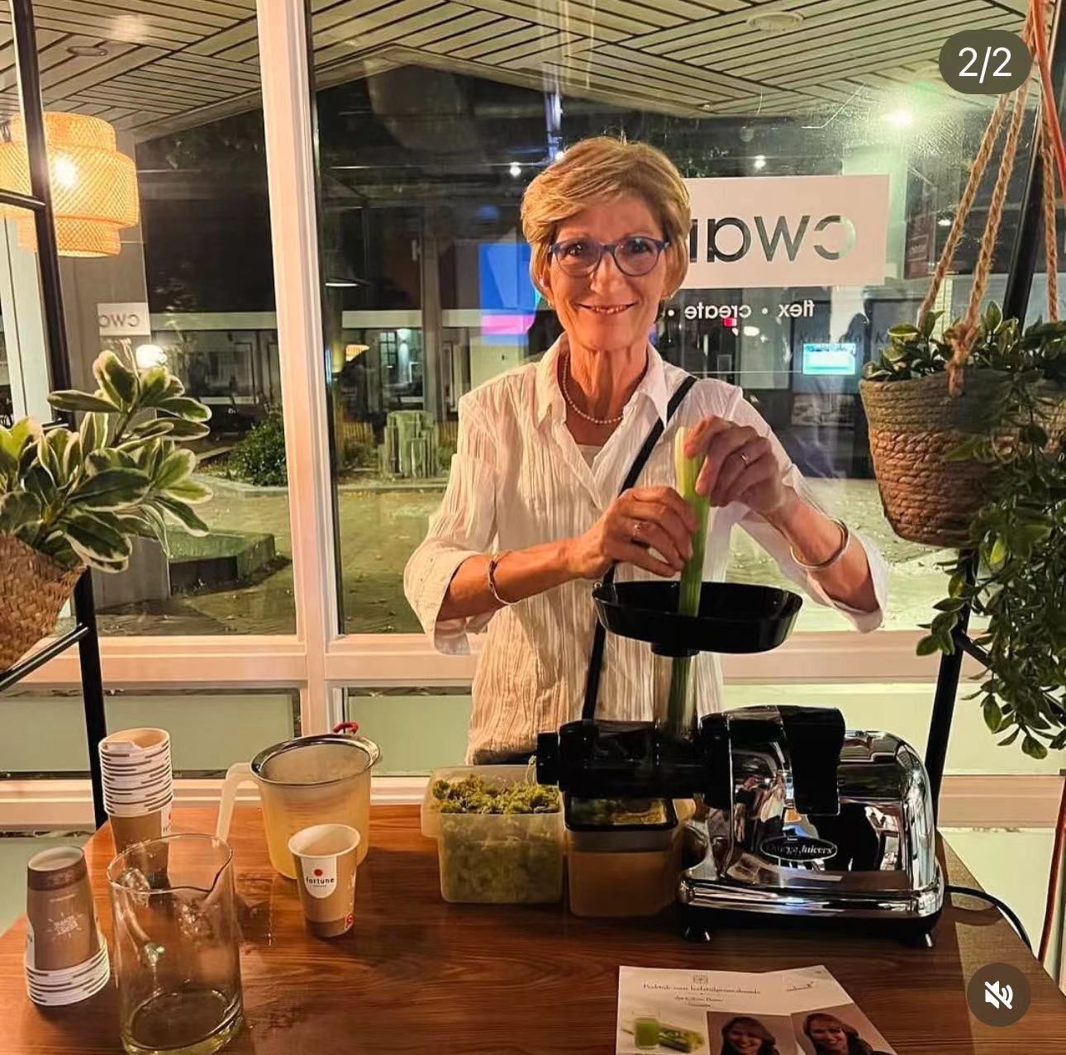

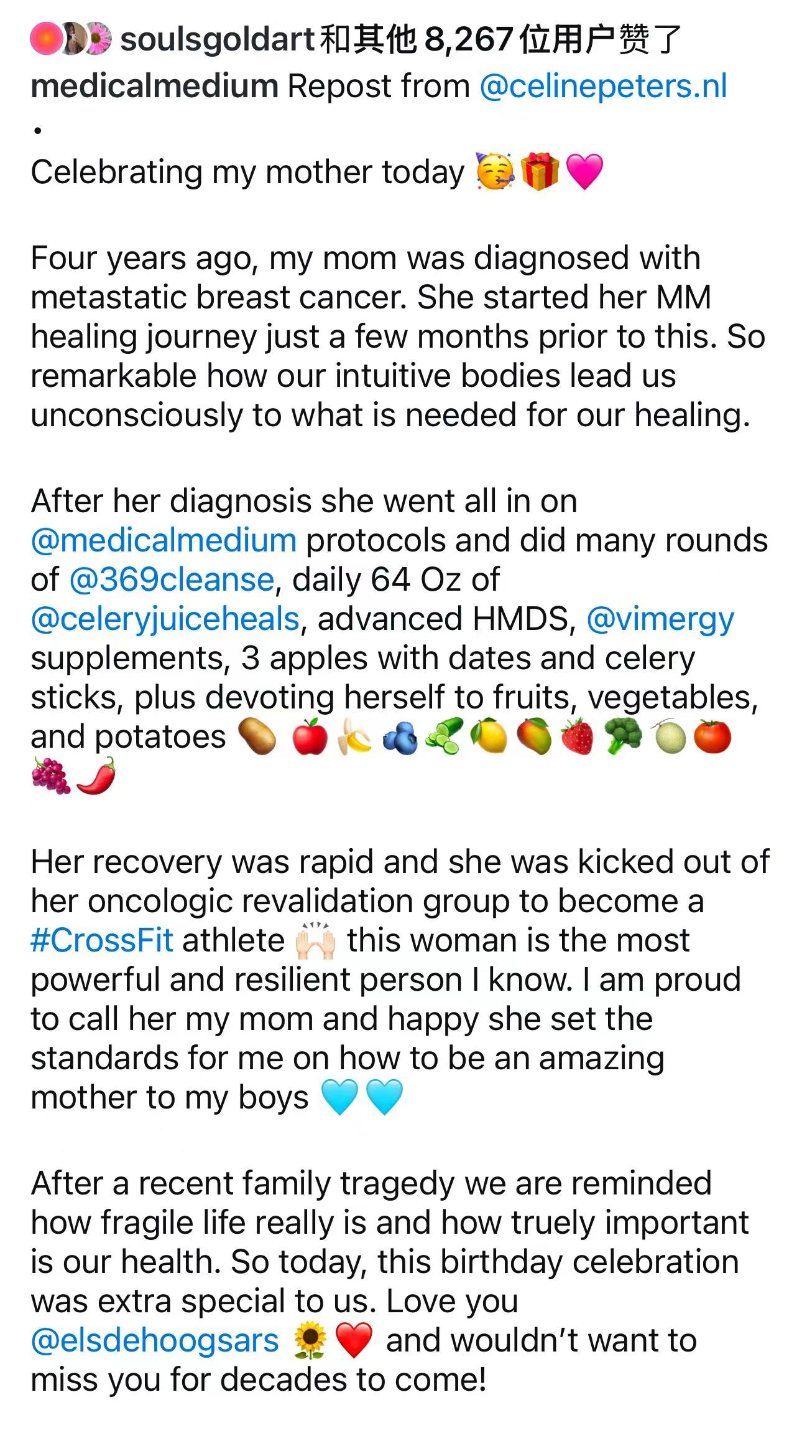

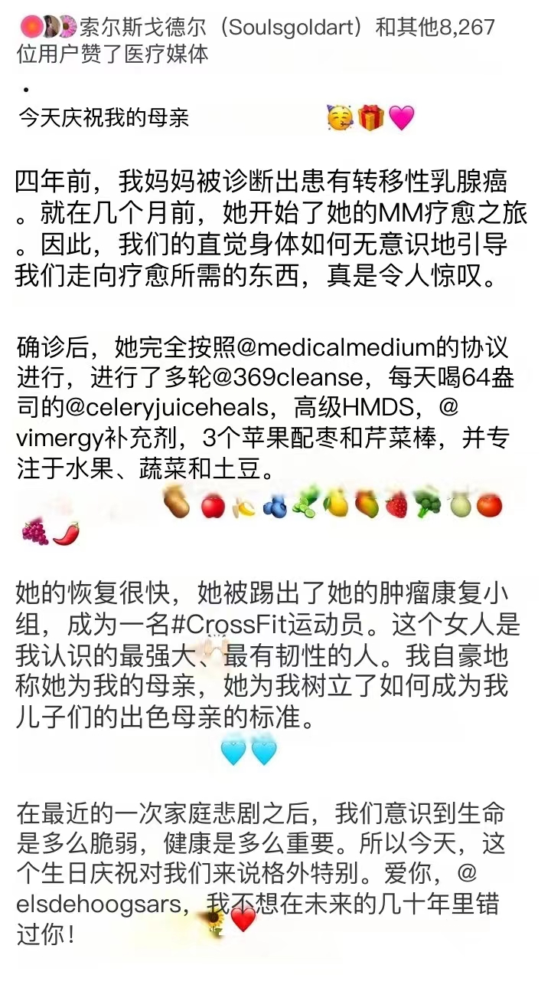

请看，国外很多安友的疗愈康复分享，都像这对母女，都很大方毫不避讳露脸，有图有真相的啊。所以，史蒂芬尼事件当中，是不是还有什么我们所不知道的真相呢？

链接：https://podcasts.apple.com/us/podcast/063-the-plotter-series-s2-e3-ashleigh-fosters-severe/id1133835109?i=1000663025724

063 The Plotter Series S2 E3: Ashleigh Foster's Severe Pattern Of Lying And InaccuracyMedical Medium Podcast

  - Health & Fitness
Listen on Apple Podcasts
The leader of the campaign to take Medical Medium down, Ashleigh Phillips Foster, gets caught in one of the most ambitious lies of all time. It is a lie that Ashleigh has been telling at least 9 different contradictory versions of, repeatedly, to anyone and everyone who would listen to her…for years. Married to Britton Foster, a documentary cinematographer, Ashleigh has been using fabricated stories to try to obtain a deal for a negative hit piece documentary on Netflix about Medical Medium. In this episode, Ashleigh Foster’s severe pattern of lying and inaccuracy is put on full display. Ashleigh also gets exposed for her twisted use of a well-known true story about a family that saved the lives of an estimated 800 Jews and other refugees during the Holocaust. She uses this story to try to make a ludicrous point about lying and portray Medical Medium negatively. In the process of doing so, Ashleigh ironically gets no less than 18 facts wrong, she expresses extremely offensive viewpoints about our duties to protect those like the Jews during the Holocaust, and Ashleigh provides a perfect example that everyone can verify of just how deeply she manipulates, butchers, and twists the stories she tells to serve her own agenda.

推翻《医学媒介》运动的领导者阿什莉-菲利普斯-福斯特陷入了一个最有野心的谎言。多年来，阿什莉对每一个愿意听她说话的人反复说了至少 9 个自相矛盾的谎言。阿什莉嫁给了纪录片摄影师布里顿-福斯特（Britton Foster），她一直在用编造的故事试图在 Netflix 上获得一部关于《医学媒介》的负面纪录片。在这一集中，阿什莉-福斯特严重的撒谎和失实模式暴露无遗。阿什莉还被揭露歪曲使用了一个众所周知的真实故事，这个故事讲述了一个家庭在大屠杀期间拯救了大约 800 名犹太人和其他难民的生命。她利用这个故事试图提出一个关于撒谎的可笑观点，并对医疗媒体进行负面描述。在这个过程中，阿什利讽刺性地弄错了不少于 18 个事实，她对我们在大屠杀期间保护犹太人等人的责任表达了极其令人反感的观点，阿什利提供了一个完美的例子，让每个人都能验证她是多么深刻地操纵、篡改和扭曲她所讲述的故事，以服务于她自己的议程。

链接：https://podcasts.apple.com/us/podcast/062-the-plotter-series-s2-e2-ashleigh-fosters-motives/id1133835109?i=1000660915379

062 The Plotter Series S2 E2: Ashleigh Foster's MotivesMedical Medium Podcast

  - Health & Fitness
Listen on Apple Podcasts
Ashleigh Foster is the number one person responsible for the plot to take down Medical Medium and all of the chronically ill people who have been harmed by it. Ashleigh Foster is the ringleader of an organized, anti-Medical Medium hateful group that she created on a mountain of lies. Ashleigh fed a false story to Vanity Fair, and another source admitted on recording that he and Ashleigh had to threaten a journalist to get him to publish it. Ashleigh’s hateful group has since been relentlessly attacking, harassing, bullying, body-shaming, and publicly humiliating people in the Medical Medium community, including mothers and children. This hateful group has even gone as far as to make videos of themselves burning Medical Medium books and to call for Anthony himself to be exterminated by fire.

Why is Ashleigh really doing this? Many have asked. What are Ashleigh’s motives? What type of person is capable of harboring, spewing, and inciting so much hatred? What type of person escalates objectively indefensible behavior even after being publicly proven wrong? Why would someone go to such lengths, secretly plotting and scheming for years, to try to bring an entire movement of people healing from chronic illness down?

In this episode, these questions are answered. Shocking new facts that are wildly inconsistent with Ashleigh’s proclamation that she’s doing this smear campaign “for Stephanie Tisone” are revealed. Ashleigh Foster’s true motives are exposed for the first time. The history that Ashleigh has been hiding from everyone is uncovered. And we begin exposing some of the many more outrageous lies that Ashleigh has peddled incessantly since the release of the first four plotter podcast episodes last year.
阿什莉又被发现不诚实了，她一次也没有去看望斯蒂芬妮

阿什莉-福斯特（Ashleigh Foster）是阴谋推翻《医学媒介》和所有受其伤害的慢性病患者的头号罪魁祸首。阿什莉-福斯特是一个有组织的反 "医学媒介 "仇恨团体的头目，这个团体是她用谎言堆砌起来的。阿什莉向 "名利场 "提供了一个虚假故事，另一个消息来源在录音中承认，他和阿什莉不得不威胁一名记者，让他发表这个故事。此后，阿什莉的仇恨团体一直在无情地攻击、骚扰、欺凌、羞辱和公开羞辱医学媒介社区的人们，包括母亲和儿童。这个充满仇恨的团体甚至还制作了焚烧《医学媒介》书籍的视频，并呼吁用火把安东尼本人烧死。

阿什利到底为什么要这么做？许多人问。阿什利的动机是什么？什么样的人能够窝藏、散布和煽动如此多的仇恨？什么样的人在被公开证明是错的之后，仍然将客观上站不住脚的行为升级？为什么有人会不惜一切代价，秘密策划和谋划多年，试图将整个慢性病患者康复运动搞垮？

本集将为您解答这些问题。令人震惊的新事实被揭露出来，这些事实与阿什莉宣称她是 "为了斯蒂芬妮-蒂松 "而进行这场抹黑运动的说法完全不符。阿什莉-福斯特的真实动机首次曝光。阿什莉一直对大家隐瞒的历史也被揭开。我们开始揭露阿什莉自去年发布前四集《阴谋家》播客以来不断兜售的更多离谱谎言。

阴谋家系列 S2 E2：阿什莉-福斯特的动机
在苹果和 Spotify 上收听这个无广告播客，链接在 @medicalmedium 的简介中
【通过DeepL.com（免费版）翻译】

